**Persistence data management**

The purpose of this section is to show the mapping of the objects/classes of the system, identified

during the analysis stage, in to the corresponding relational database.

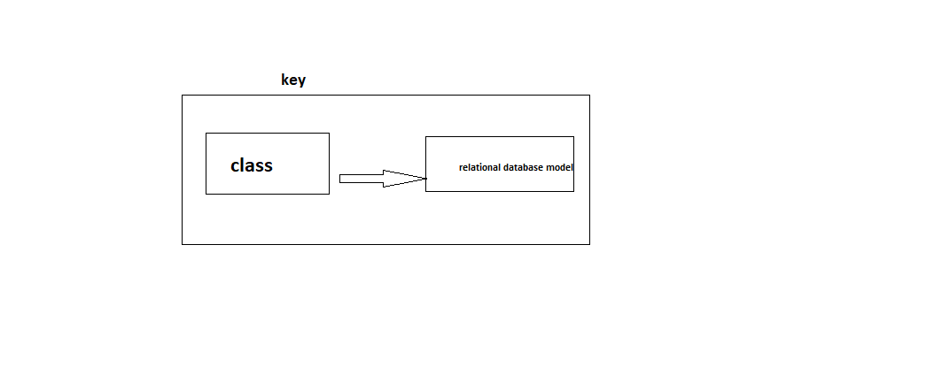



player mapping



coach mapping



playerlist mapping



account mapping



scoreboard mapping



fixtureboard mapping



adminstration mapping



card mapping



referee mapping



**Database design**

